**Submitted to:**

Ms. Anjali Mehta

Assistant Professsor

**B.S. Anangpuria Institute of Technology and Management**

**Alampur, Ballabgarh-Sohna Road, Faridabad**



**DBMS LAB**

**File**

**Submitted by:**

Brijesh Kumar Sharma

Roll No.:18/CS-09

**Index**

|  |  |
| --- | --- |
| **S.No.** | **AIM** |
| **1.** | Introduction to DBMS. |
| **2.** | Introduction to SQL. |
| **3.** | Commands in SQL. |

**PRACTICAL NO. 1**

**Introduction to DBMS**

**DBMS:**

**Database Management System (DBMS)** is a software for storing and retrieving users' data while considering appropriate security measures. It consists of a group of programs which manipulate the database. The DBMS accepts the request for data from an application and instructs the operating system to provide the specific data. In large systems, a DBMS helps users and other third-party software to store and retrieve data.

DBMS allows users to create their own databases as per their requirement. The term “DBMS” includes the user of the database and other application programs. It provides an interface between the data and the software application.

**Example:**

Let us see a simple example of a university database. This database is maintaining information concerning students, courses, and grades in a university environment. The database is organized as five files:

* The STUDENT file stores data of each student
* The COURSE file stores contain data on each course.
* The SECTION stores the information about sections in a particular course.
* The GRADE file stores the grades which students receive in the various sections
* The TUTOR file contains information about each professor.

**Popular DBMS Software:**

Here, is the list of some popular DBMS system:

* MySQL
* Microsoft Access
* Oracle
* PostgreSQL
* dBASE
* FoxPro
* SQLite
* IBM DB2
* LibreOffice Base
* MariaDB
* Microsoft SQL Server etc.

**Database:**

A database is a collection of related data which represents some aspect of the real world. A

database system is designed to be built and populated with data for a certain task.

## Data:

Data is a raw and unorganized fact that required to be processed to make it meaningful. Data can be simple at the same time unorganized unless it is organized. Generally, data comprises facts, observations, perceptions numbers, characters, symbols, image, etc.

Data is always interpreted, by a human or machine, to derive meaning. So, data is meaningless. Data contains numbers, statements, and characters in a raw form.

## Information:

Information is a set of data which is processed in a meaningful way according to the given requirement. Information is processed, structured, or presented in a given context to make it meaningful and useful.

It is processed data which includes data that possess context, relevance, and purpose. It also involves manipulation of raw data.

Information assigns meaning and improves the reliability of the data. It helps to ensure undesirability and reduces uncertainty. So, when the data is transformed into information, it never has any useless details.

## Components of DBMS:

DBMS have several components, each performing very significant tasks in the database management system environment. Below is a list of components within the database and its environment.

***Software***  
This is the set of programs used to control and manage the overall database. This includes the DBMS software itself, the Operating System, the network software being used to share the data among users, and the application programs used to access data in the DBMS.

***Hardware***  
Consists of a set of physical electronic devices such as computers, I/O devices, storage devices, etc., this provides the interface between computers and the real world systems.

***Data***  
DBMS exists to collect, store, process and access data, the most important component. The database contains both the actual or operational data and the metadata.

***Procedures***  
These are the instructions and rules that assist on how to use the DBMS, and in designing and running the database, using documented procedures, to guide the users that operate and manage it.

***Database Access Language***  
This is used to access the data to and from the database, to enter new data, update existing data, or retrieve required data from databases. The user writes a set of appropriate commands in a database access language, submits these to the DBMS, which then processes the data and generates and displays a set of results into a user readable form.

***Query Processor***  
This transforms the user queries into a series of low level instructions. This reads the online user’s query and translates it into an efficient series of operations in a form capable of being sent to the run time data manager for execution.

***Run Time Database Manager***  
Sometimes referred to as the database control system, this is the central software component of the DBMS that interfaces with user-submitted application programs and queries, and handles database access at run time. Its function is to convert operations in user’s queries. It provides control to maintain the consistency, integrity and security of the data.

***Data Manager***  
Also called the cache manger, this is responsible for handling of data in the database, providing a recovery to the system that allows it to recover the data after a failure.

***Database Engine***  
The core service for storing, processing, and securing data, this provides controlled access and rapid transaction processing to address the requirements of the most demanding data consuming applications. It is often used to create relational databases for online transaction processing or online analytical processing data.

***Data Dictionary***  
This is a reserved space within a database used to store information about the database itself. A data dictionary is a set of read-only table and views, containing the different information about the data used in the enterprise to ensure that database representation of the data follow one standard as defined in the dictionary.

***Report Writer***  
Also referred to as the report generator, it is a program that extracts information from one or more files and presents the information in a specified format. Most report writers allow the user to select records that meet certain conditions and to display selected fields in rows and columns, or also format the data into different charts.

**Characteristics of Database Management System:**

* Provides security and removes redundancy
* Self-describing nature of a database system
* Insulation between programs and data abstraction
* Support of multiple views of the data
* Sharing of data and multiuser transaction processing
* DBMS allows entities and relations among them to form tables.
* It follows the ACID concept ( Atomicity, Consistency, Isolation, and Durability).
* DBMS supports multi-user environment that allows users to access and manipulate data in parallel.

## Uses/Applications of DBMS:

|  |  |
| --- | --- |
| **Sector** | **Use of DBMS** |
| Banking | For customer information, account activities, payments, deposits, loans, etc. |
| Airlines | For reservations and schedule information. |
| Universities | For student information, course registrations, colleges and grades. |
| Telecommunication | It helps to keep call records, monthly bills, maintaining balances, etc. |
| Finance | For storing information about stock, sales, and purchases of financial instruments like stocks and bonds. |
| Sales | Use for storing customer product and sales information. |
| Manufacturing | Used for the management of supply chain and for tracking production of items. Inventories status in warehouses. |
| HR Management | For information about employees, salaries, payroll, deduction, generation of paychecks, etc. |

**PRACTICAL NO. 2**

**Introduction to SQL**

**SQL:**

Structure Query Language(SQL) is a database query language used for storing and managing data in Relational DBMS. SQL was the first commercial language introduced for E.F Codd's **Relational** model of database. Today almost all RDBMS(MySql, Oracle, Infomix, Sybase, MS Access) use **SQL** as the standard database query language. SQL is used to perform all types of data operations in RDBMS.

**History of SQL:**

SQL was initially developed at [IBM](https://en.wikipedia.org/wiki/IBM) by [Donald D. Chamberlin](https://en.wikipedia.org/wiki/Donald_D._Chamberlin) and [Raymond F. Boyce](https://en.wikipedia.org/wiki/Raymond_F._Boyce) after learning about the relational model from [Edgar F. Codd](https://en.wikipedia.org/wiki/Edgar_F._Codd) in the early 1970s. This version, initially called *SEQUEL* (*Structured English Query Language*), was designed to manipulate and retrieve data stored in [IBM](https://en.wikipedia.org/wiki/IBM)'s original quasi-relational database management system, [System R](https://en.wikipedia.org/wiki/IBM_System_R), which a group at [IBM San Jose Research Laboratory](https://en.wikipedia.org/wiki/IBM_Almaden_Research_Center) had developed during the 1970s.

Chamberlin and Boyce's first attempt at a relational database language was Square, but it was difficult to use due to subscript notation. After moving to the San Jose Research Laboratory in 1973, they began work on SEQUEL. The acronym SEQUEL was later changed to SQL because "SEQUEL" was a [trademark](https://en.wikipedia.org/wiki/Trademark) of the [UK-based](https://en.wikipedia.org/wiki/United_Kingdom) [Hawker Siddeley](https://en.wikipedia.org/wiki/Hawker_Siddeley) Dynamics Engineering Limited company.

After testing SQL at customer test sites to determine the usefulness and practicality of the system, IBM began developing commercial products based on their System R prototype including [System/38](https://en.wikipedia.org/wiki/IBM_System/38), [SQL/DS](https://en.wikipedia.org/wiki/IBM_SQL/DS), and [DB2](https://en.wikipedia.org/wiki/IBM_DB2), which were commercially available in 1979, 1981, and 1983, respectively.

In the late 1970s, Relational Software, Inc. (now [Oracle Corporation](https://en.wikipedia.org/wiki/Oracle_Corporation)) saw the potential of the concepts described by Codd, Chamberlin, and Boyce, and developed their own SQL-based [RDBMS](https://en.wikipedia.org/wiki/Relational_database) with aspirations of selling it to the [U.S. Navy](https://en.wikipedia.org/wiki/United_States_Navy), [Central Intelligence Agency](https://en.wikipedia.org/wiki/Central_Intelligence_Agency), and other [U.S. government](https://en.wikipedia.org/wiki/Federal_government_of_the_United_States) agencies. In June 1979, Relational Software, Inc. introduced the first commercially available implementation of SQL, [Oracle](https://en.wikipedia.org/wiki/Oracle_Database) V2 (Version2) for [VAX](https://en.wikipedia.org/wiki/VAX) computers.

By 1986, [ANSI](https://en.wikipedia.org/wiki/ANSI) and [ISO](https://en.wikipedia.org/wiki/ISO) standard groups officially adopted the standard "Database Language SQL" language definition. New versions of the standard were published in 1989, 1992, 1996, 1999, 2003, 2006, 2008, 2011and, most recently, 2016.

**Different SQL languages:**

There are five types of SQL commands: DDL, DML, DCL, TCL, and DQL.

### **1. Data Definition Language (DDL)**

* DDL changes the structure of the table like creating a table, deleting a table, altering a table, etc.
* All the command of DDL are auto-committed that means it permanently save all the changes in the database.

Here are some commands that come under DDL:

* CREATE
* ALTER
* DROP
* TRUNCATE

### **2. Data Manipulation Language**

* DML commands are used to modify the database. It is responsible for all form of changes in the database.
* The command of DML is not auto-committed that means it can't permanently save all the changes in the database. They can be rollback.

Here are some commands that come under DML:

* INSERT
* UPDATE
* DELETE

### **3. Data Control Language**

DCL commands are used to grant and take back authority from any database user.

Here are some commands that come under DCL:

* Grant
* Revoke

### **4. Transaction Control Language**

TCL commands can only use with DML commands like INSERT, DELETE and UPDATE only.

These operations are automatically committed in the database that's why they cannot be used while creating tables or dropping them.

Here are some commands that come under TCL:

* COMMIT
* ROLLBACK
* SAVEPOINT

### **5. Data Query Language**

DQL is used to fetch the data from the database.

It uses only one command:

* SELECT

**Uses of SQL:**

* You can create a new database with SQL,
* You can insert new data in the database,
* You can modify or update your previous data,
* You can retrieve your data from the database,
* You can delete your data,
* You can create a new table in one database or even drop the table,
* You can set permissions for table, procedures and views, and
* You can create function, views and stored procedures

Hence, in a database management system, all works are accomplished with the assistance of SQL.

**Applications of SQL:**

Here, we will see some applications of SQL that render it so valuable in a data-driven world where governing massive databases is the criterion of the day.

* SQL is used as a***Data Definition Language (DDL)***which means you can autonomously make a database, characterize its structure, use it and afterwards dispose of it when you are finished with it. It is additionally conveyed as a ***Data Control Language (DCL)*** which determines how you can ensure your information base against debasement and misuse.
* SQL is used as a***Data Manipulation Language (DML)***which implies you can use it for keeping up a previously existing database. Hence, it is an incredible language for entering information, changing information, and separating information with respect to a database.
* It is broadly used as a***Client or Server language***to interface the front-end with the back-end consequently supporting the customer or worker architecture. Likewise, it can be used in the three-level design of a customer, an application worker, and a database which characterizes the Internet architecture.

**PRACTICAL NO. 3**

**Commands in SQL:**

**SQL commands:**

* SQL commands are instructions. It is used to communicate with the database. It is also used to perform specific tasks, functions, and queries of data.
* SQL can perform various tasks like create a table, add data to tables, drop the table, modify the table, set permission for users.

**COMMANDS:**

**1. How to create a table-**

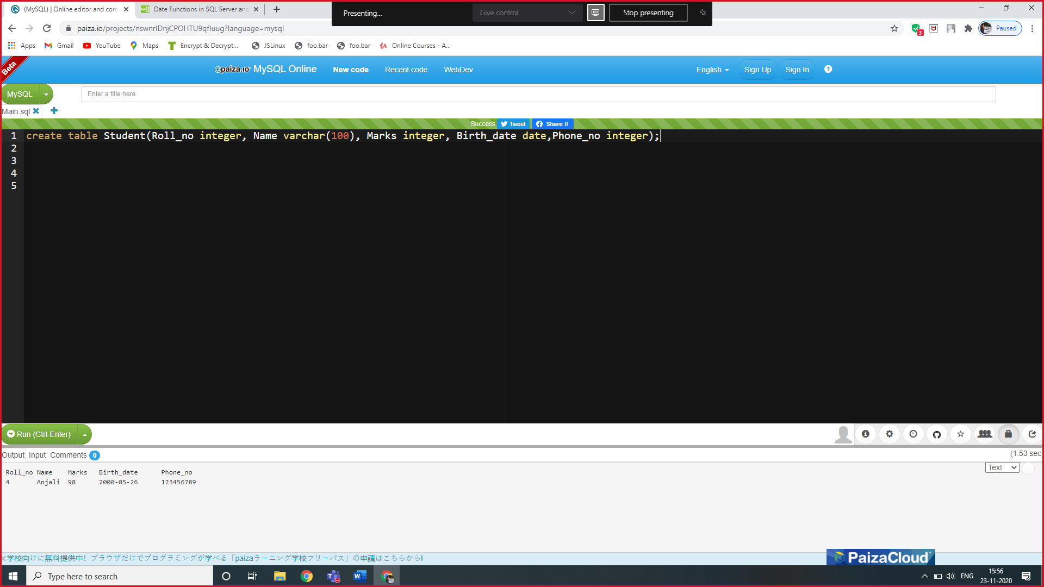

**2. How to insert the data/values into the table-**

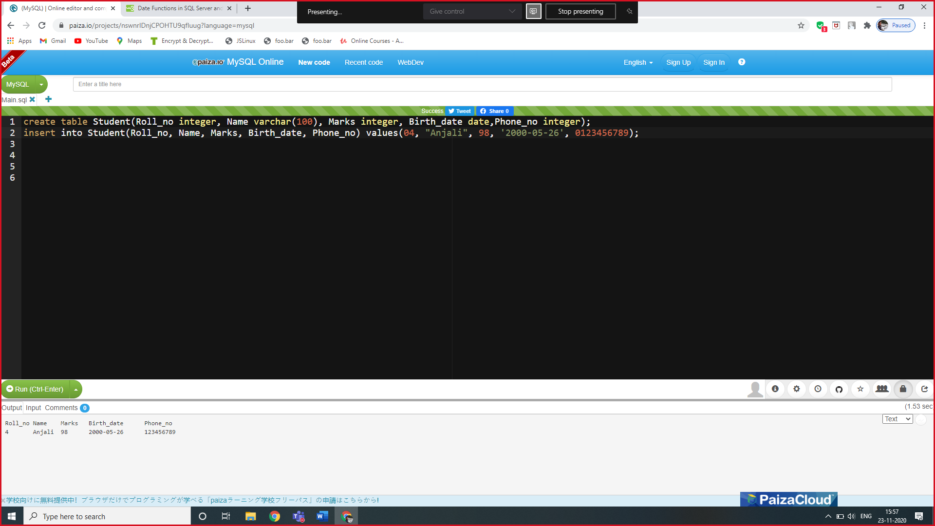

**3. How to display the table-**

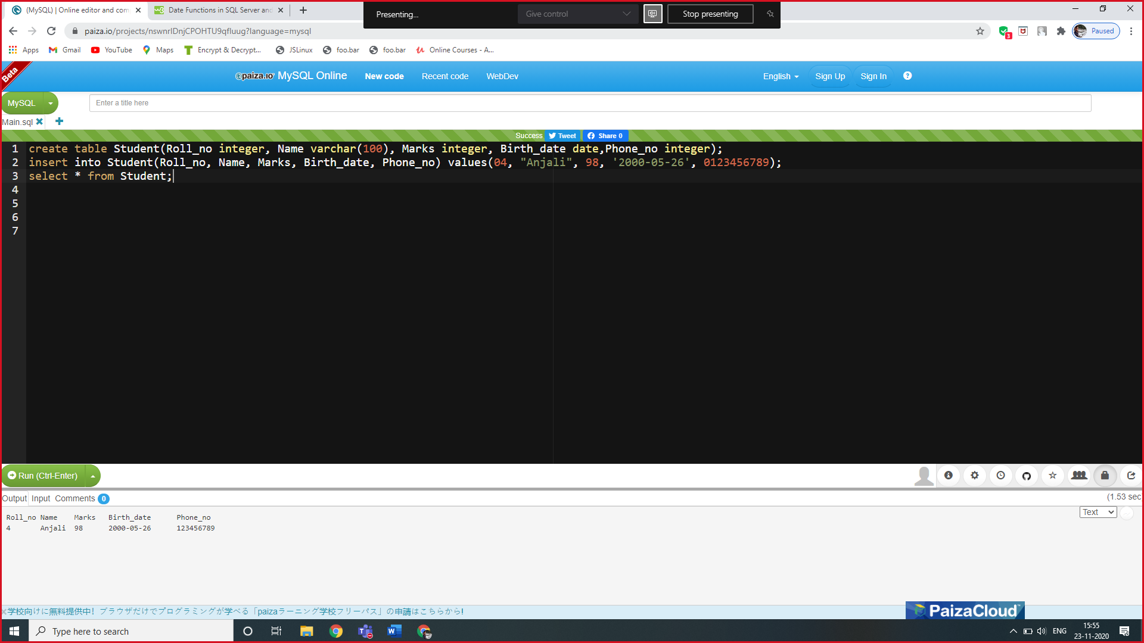

**Output-**

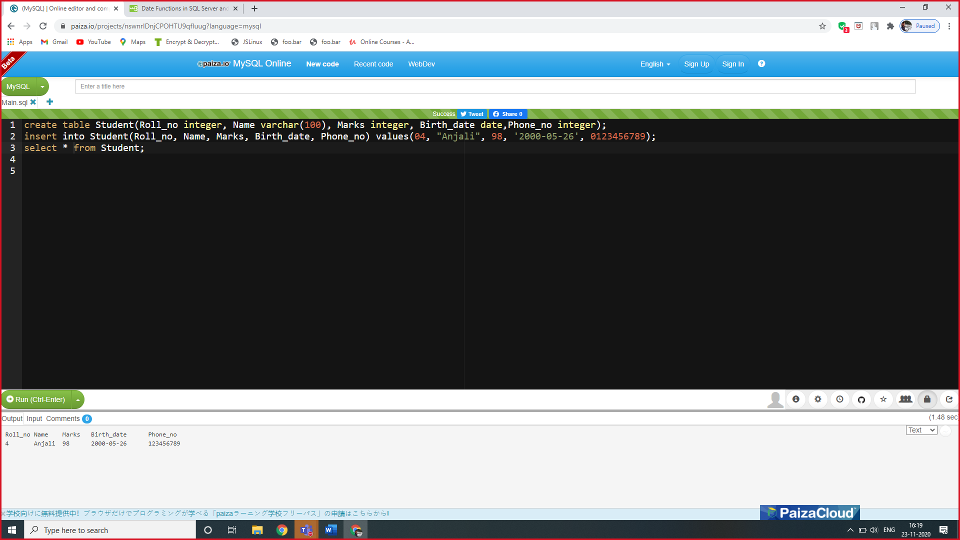

**4. How to display a particular column of a table-**

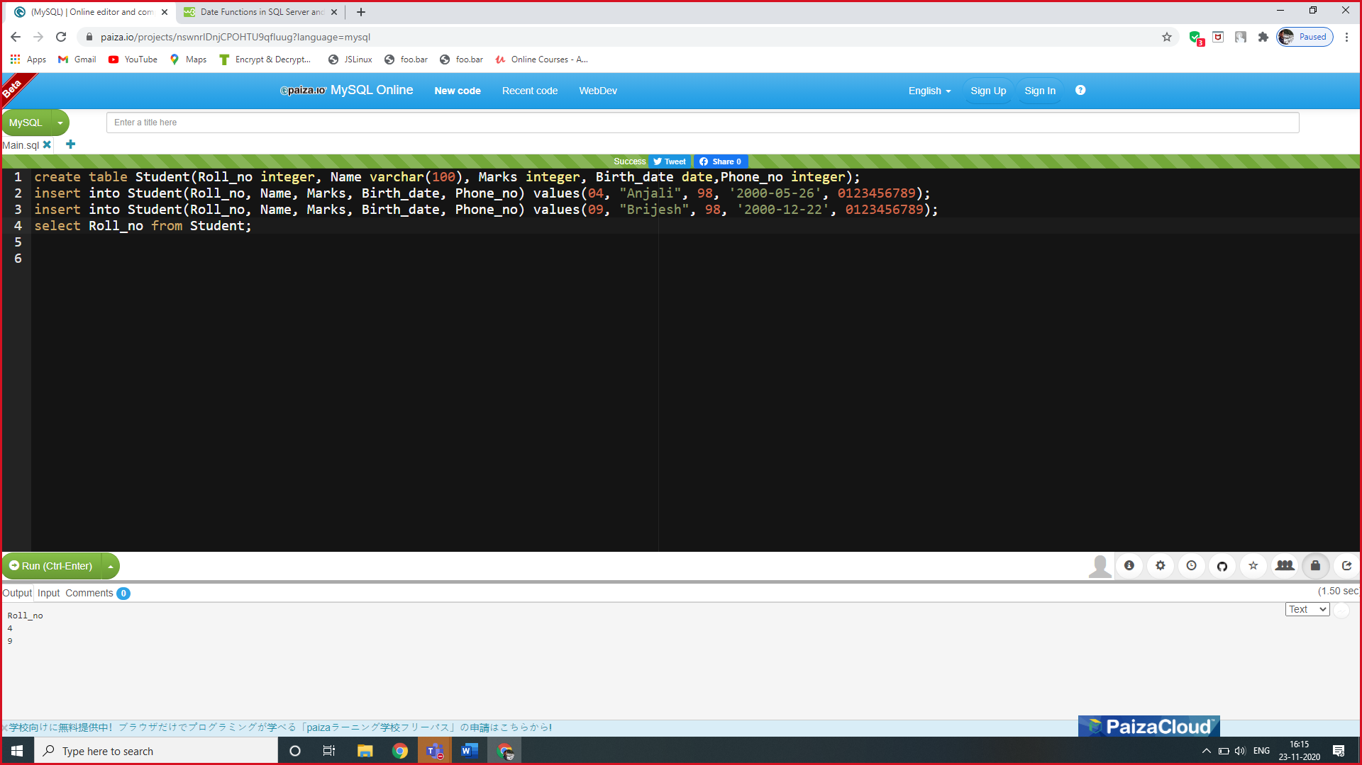

**Output-**



**5. How to drop or delete a table-**

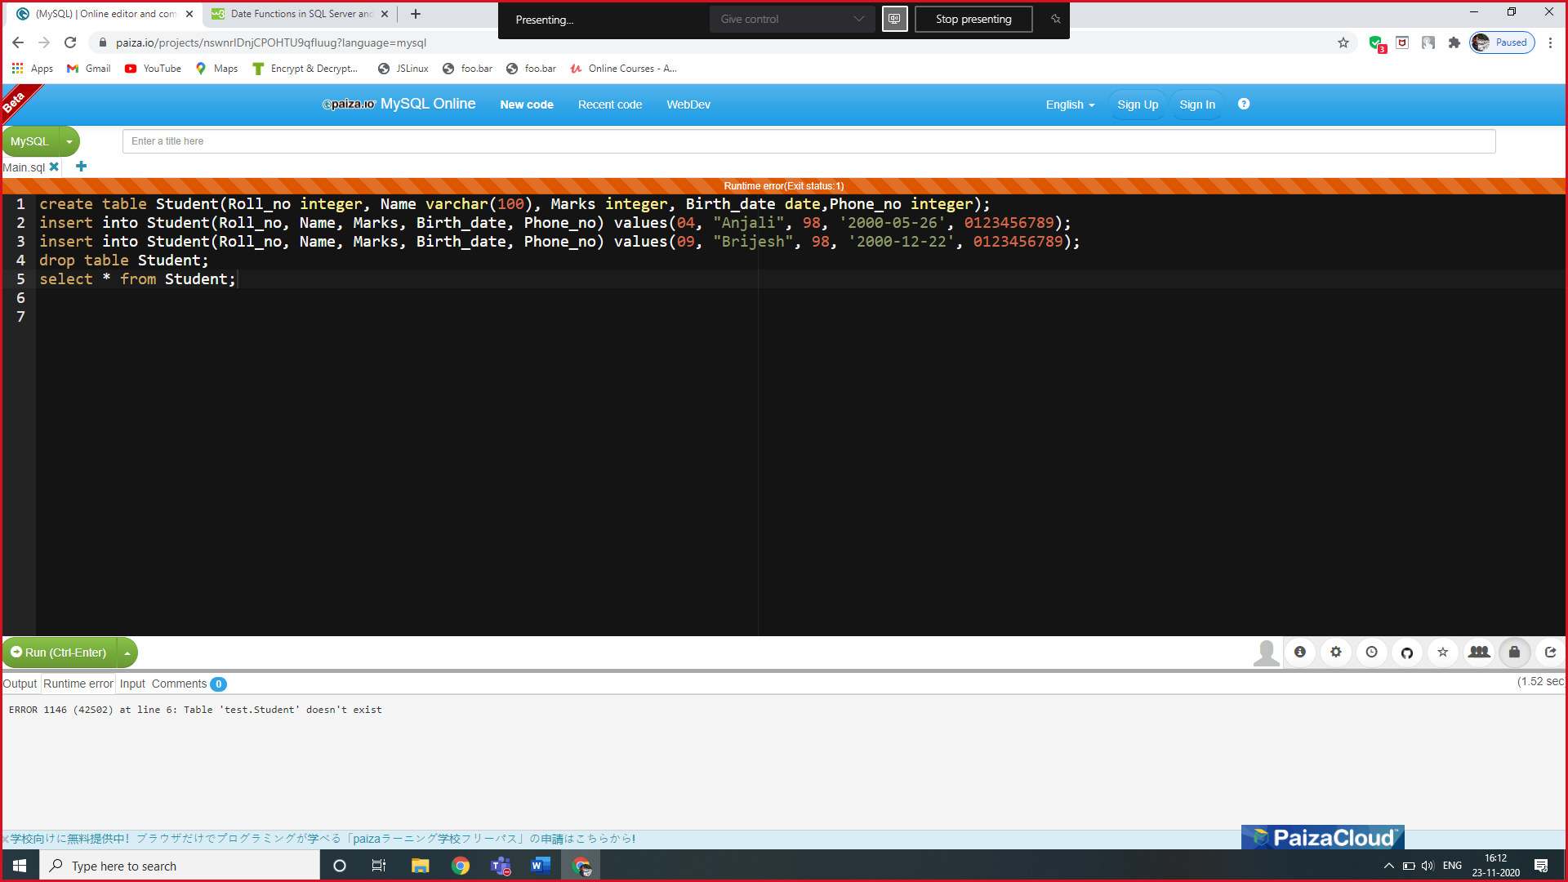

**Output-**

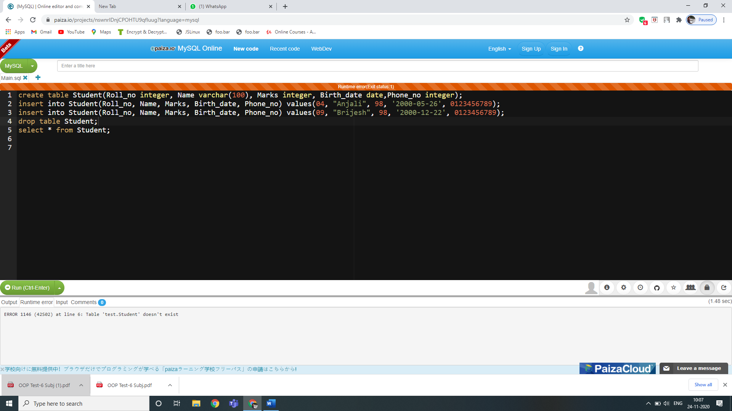

**6. How to describe/see the description ofa table-**

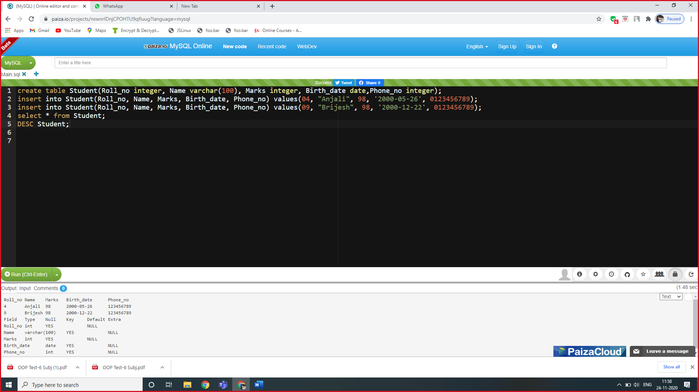

**Output-**



**7. How to add or multiply a particular integer to a column-**

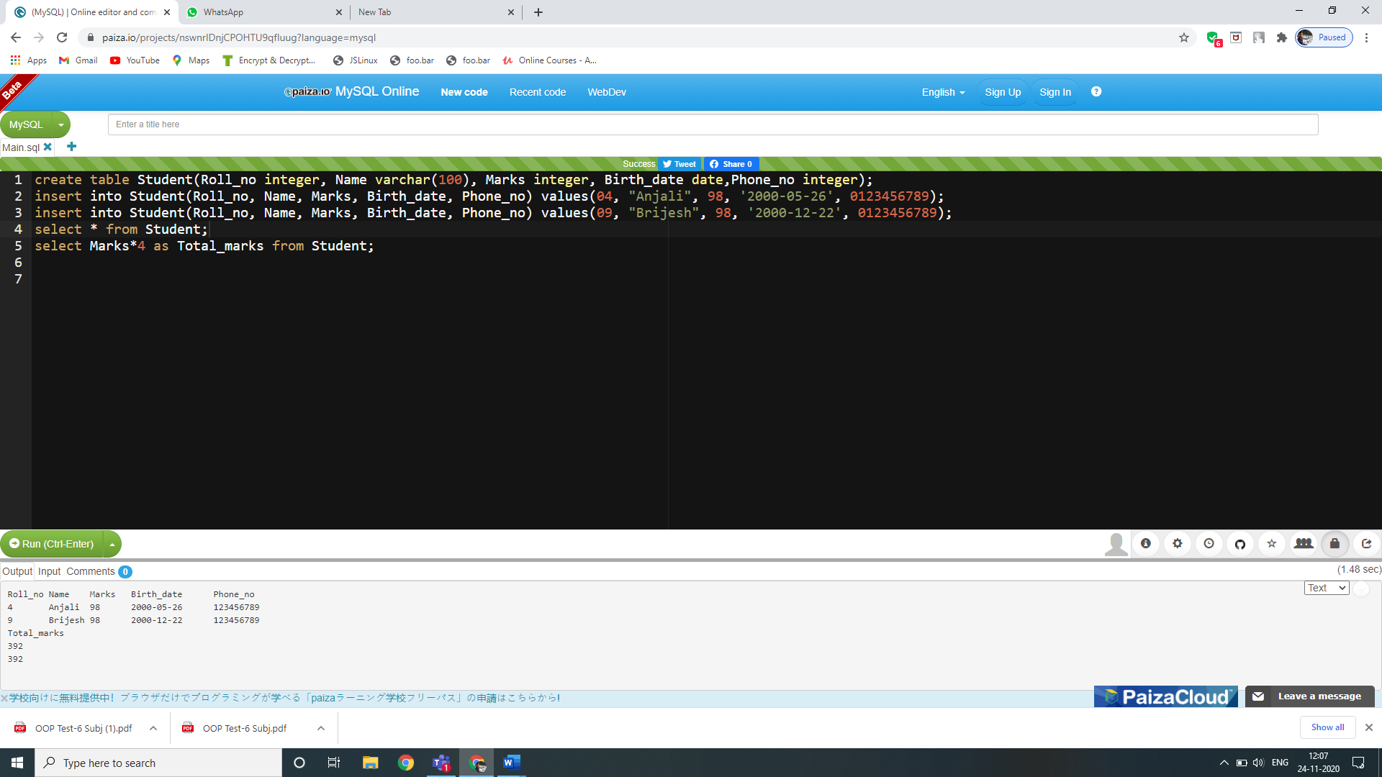

**Output-**



**8. How to see the distinct values of a column to avoid repeatition-**

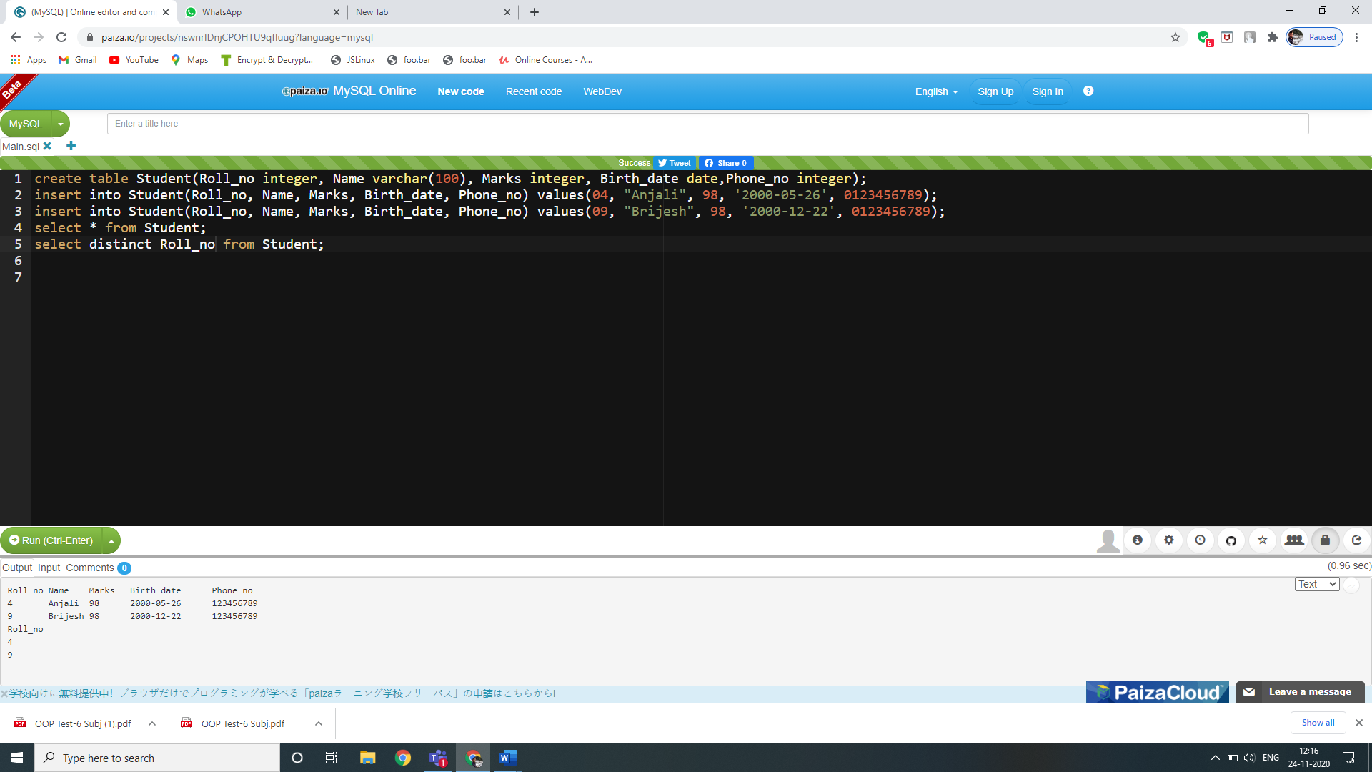

**Output-**



**9. How to display the count of particular distinct values-**

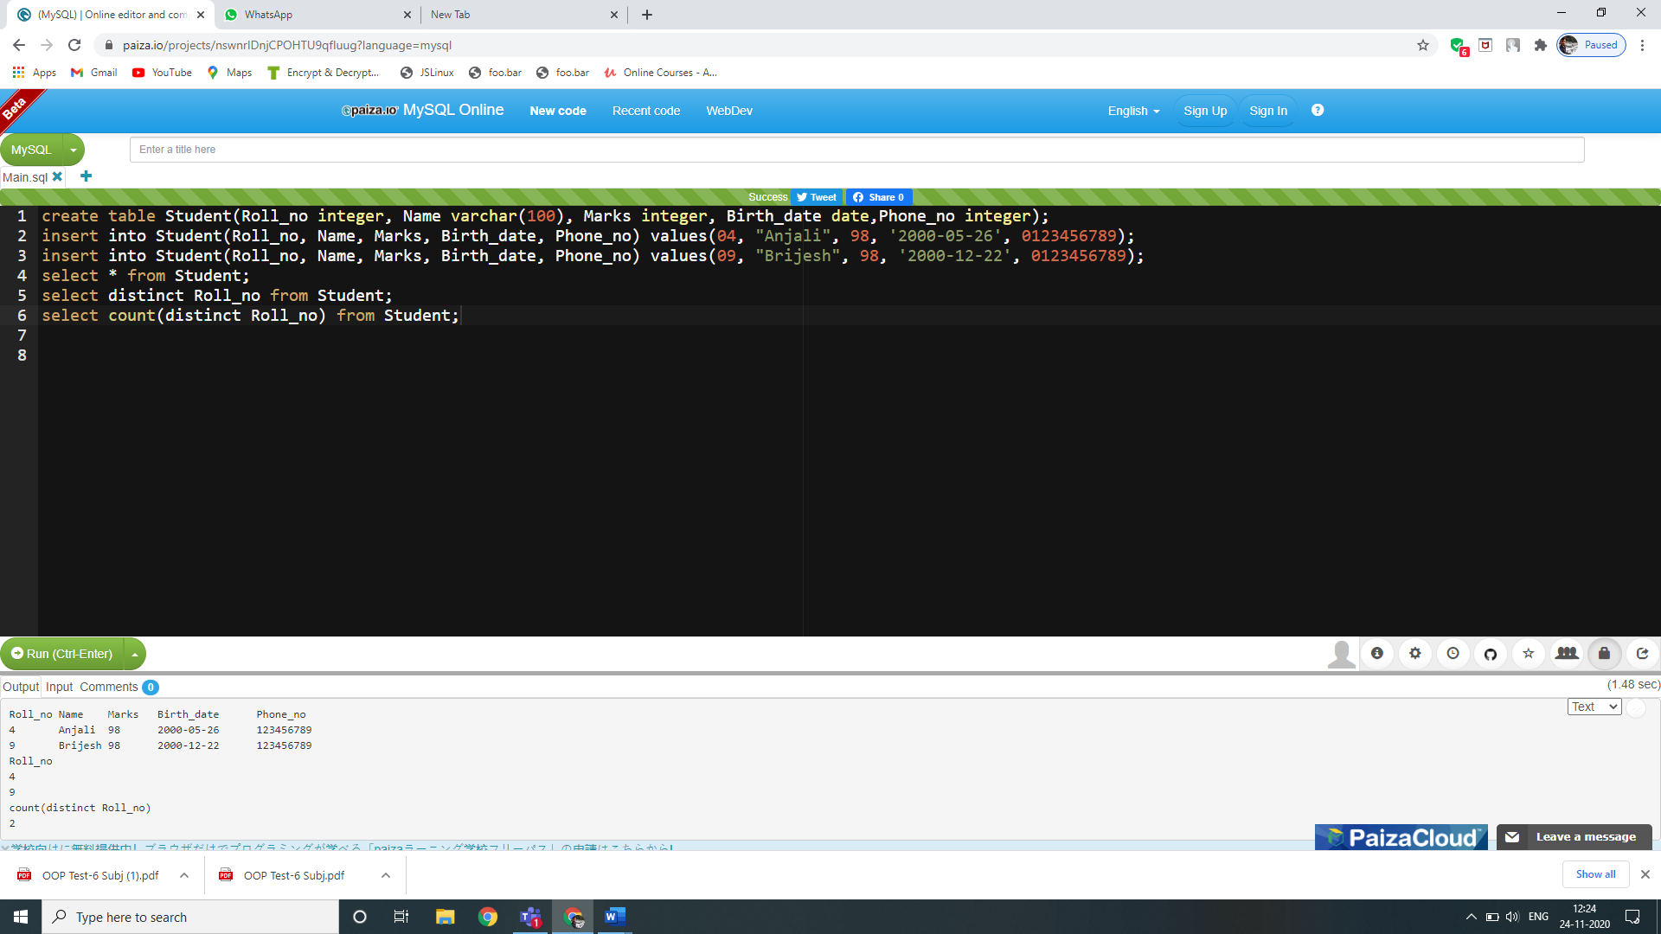

**Output-**



**10. How to use BETWEEN operator to select values within a given range-**

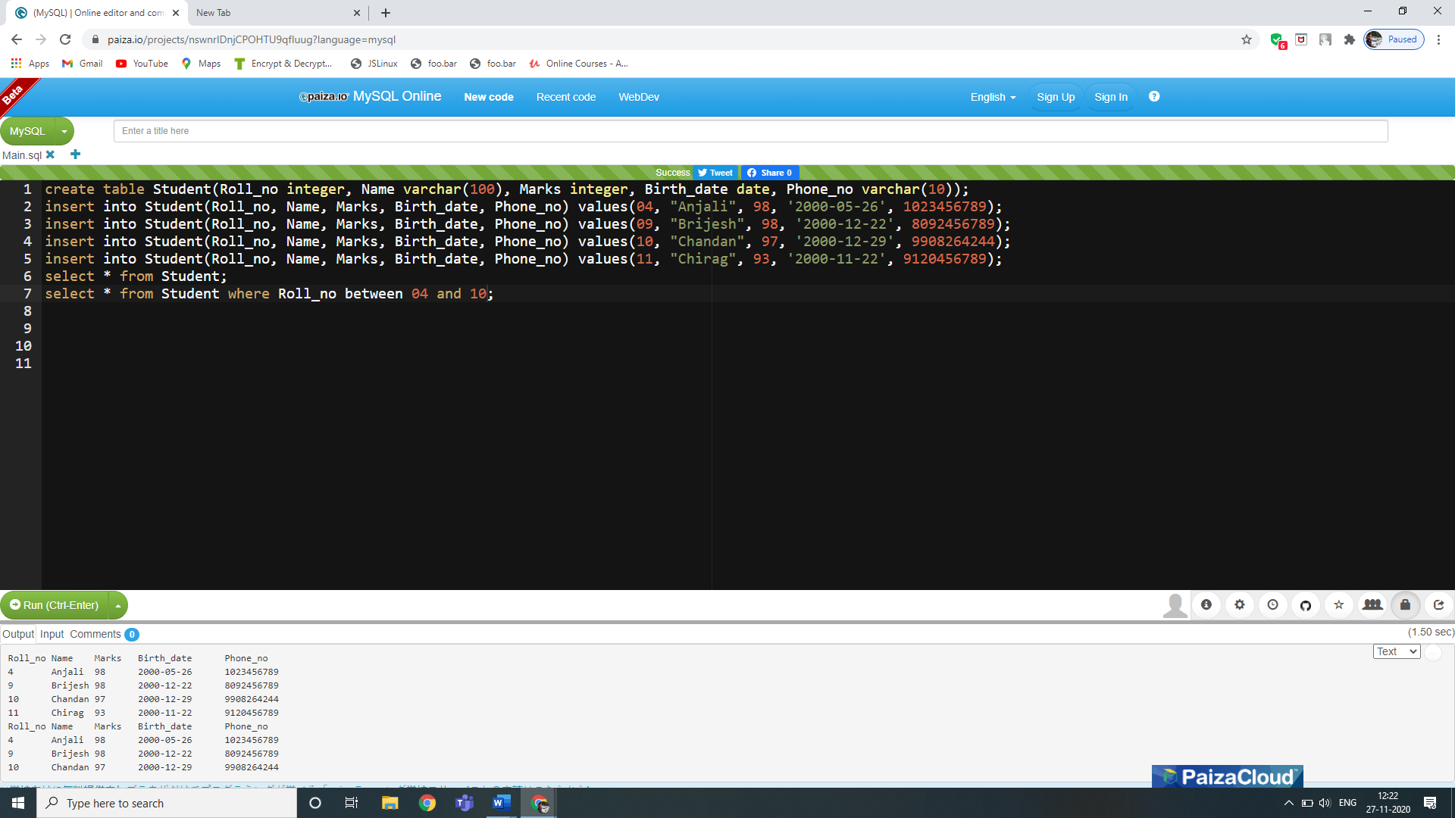

**Output-**



**11. How to use LIKE operator in WHERE clause to search for a specified pattern(starting with a specified value) in a column-**

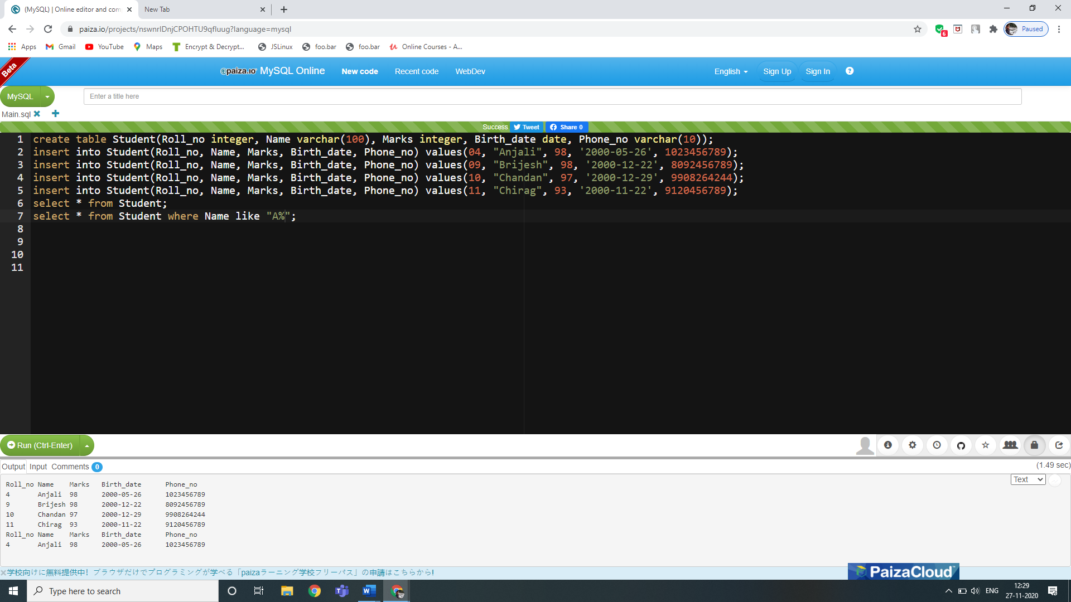

**Output-**



**12. How to use LIKE operator in WHERE clause to search for a specified pattern(ending with a specified value) in a column-**

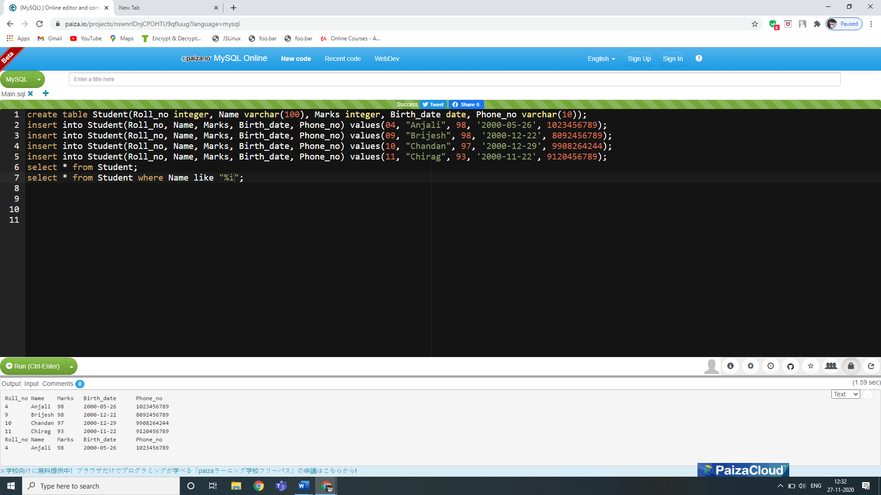

**Output-**



**13. . How to use LIKE operator in WHERE clause to search for a specified pattern(inbetween a specified value) in a column-**

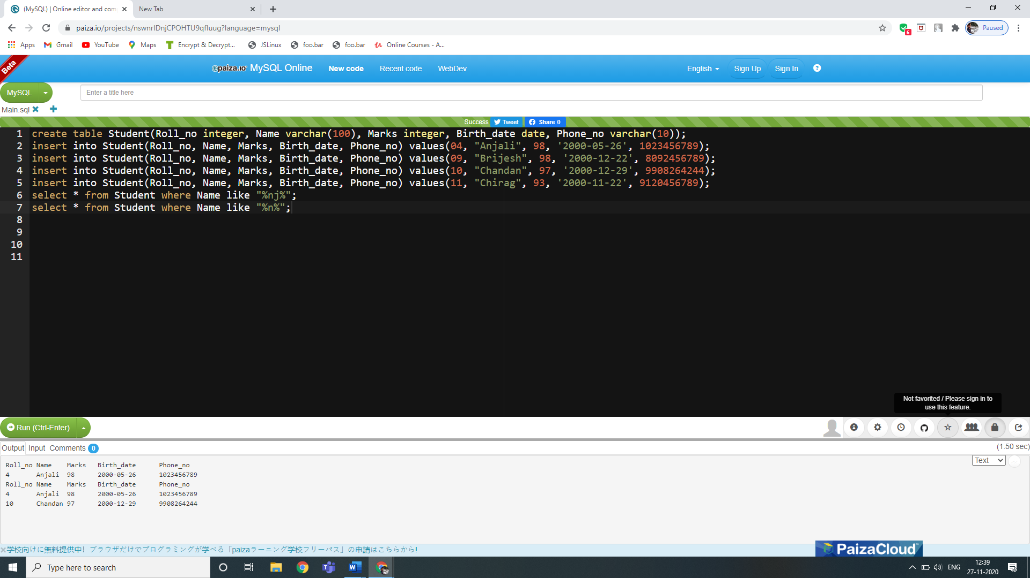

**Output-**



**14. How to use IN operator to specify multiple values in a WHERE clause-**

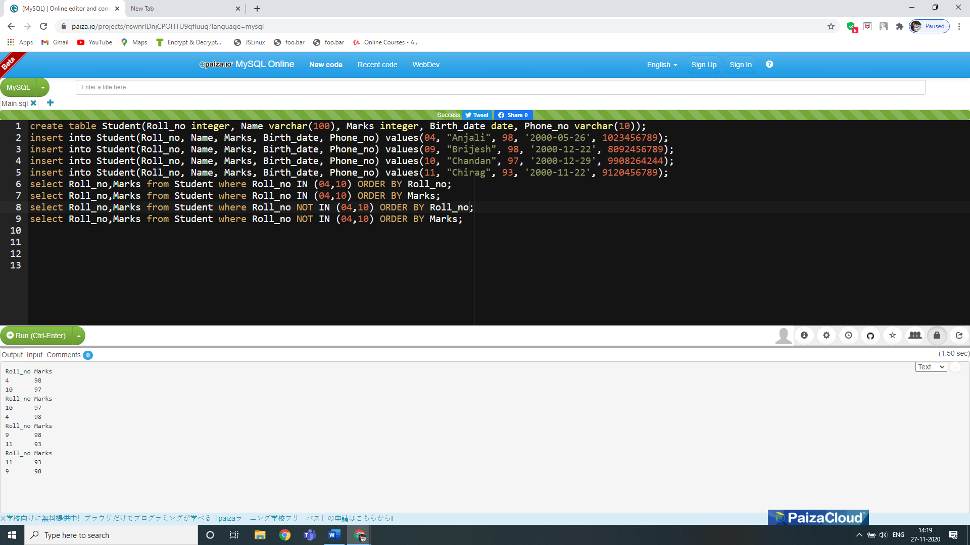

**Output-**



**SQL Aggregate Functions/Operators- AVG, COUNT, MIN, MAX, SUM**

**15. How to use MAX function to get the maximum value in a set of values-**

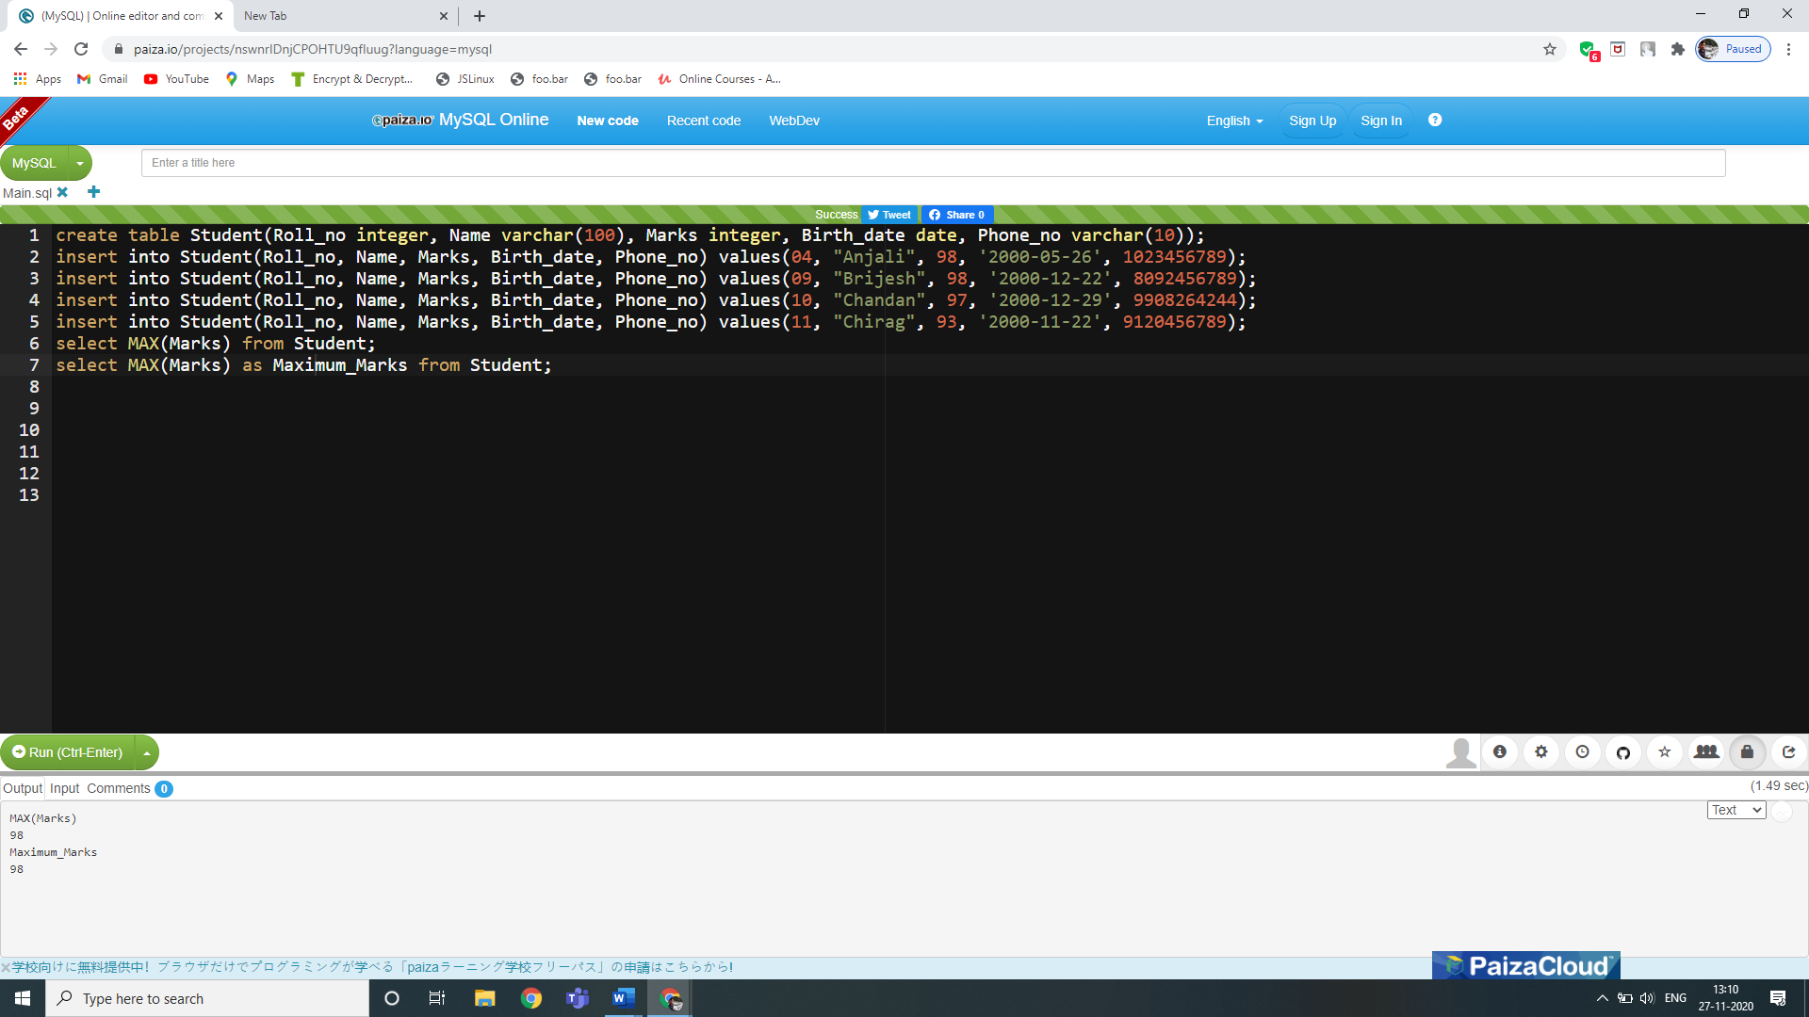

**Output-**

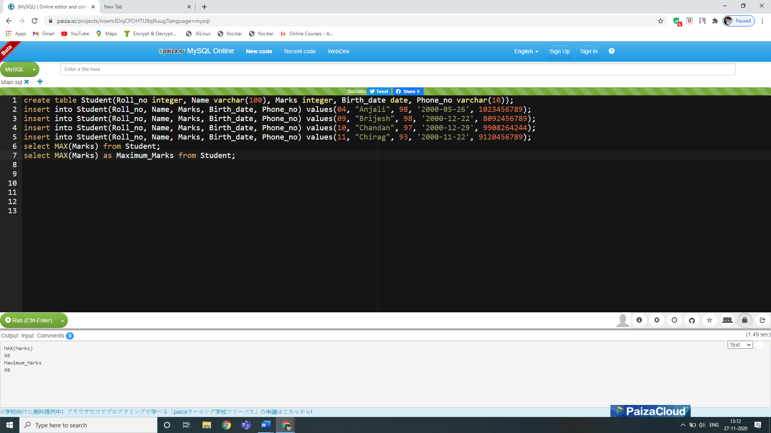

**16. How to use MIN function to get the minimum value in a set of values-**

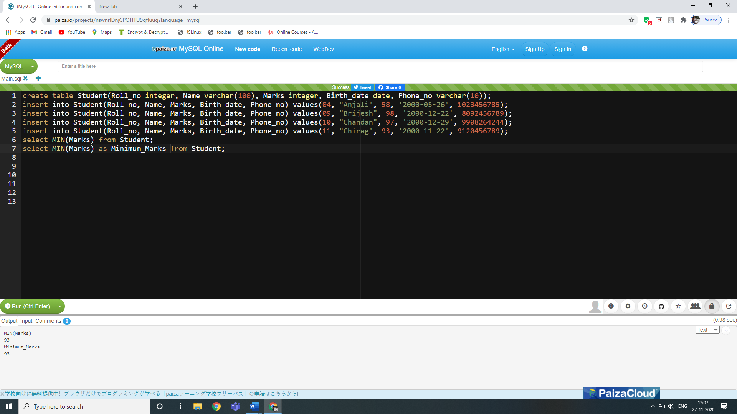

**Output-**



**17. How to use SUM function to calculate the sum of values-**

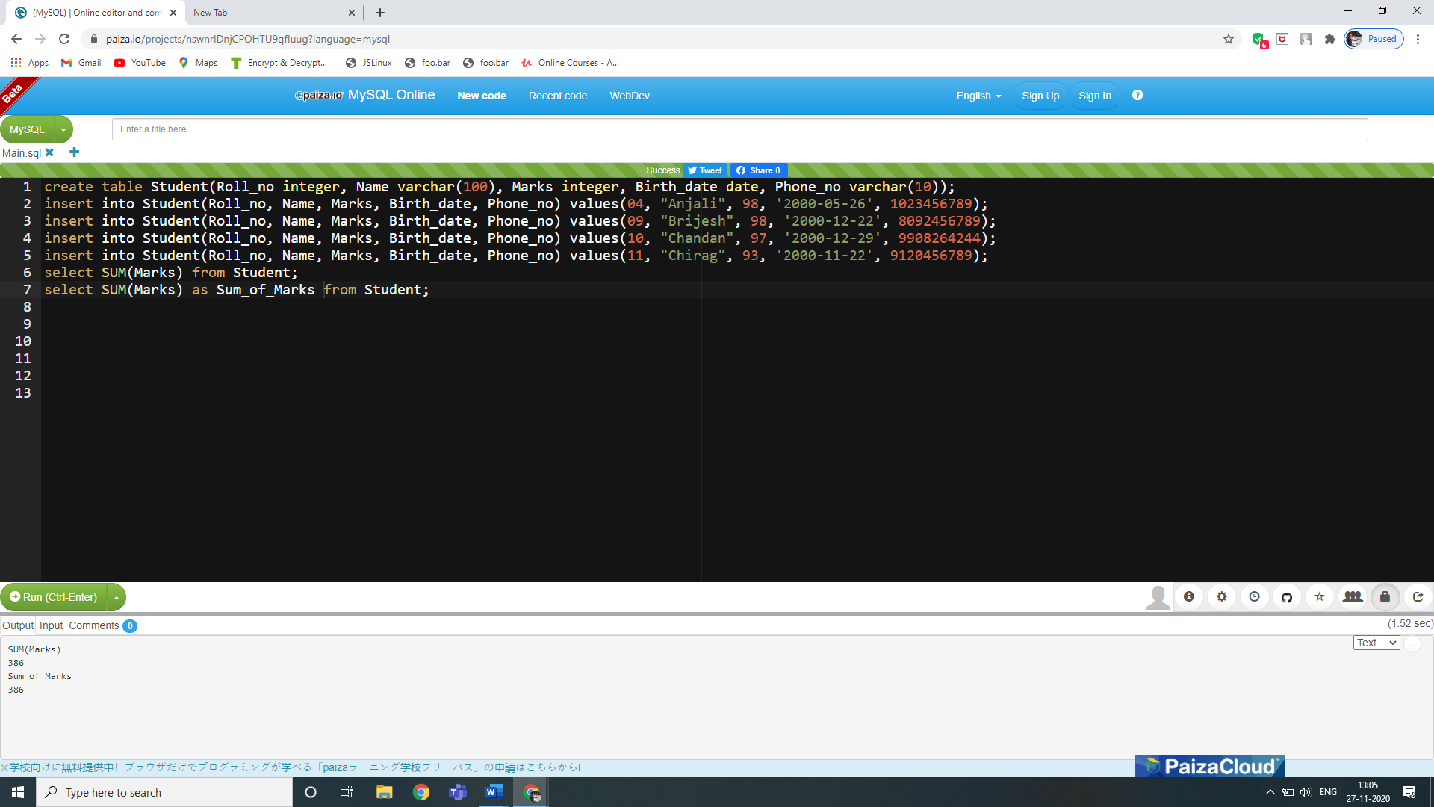

**Output-**



**18. How to use AVG function to calculate the average of a set of values-**

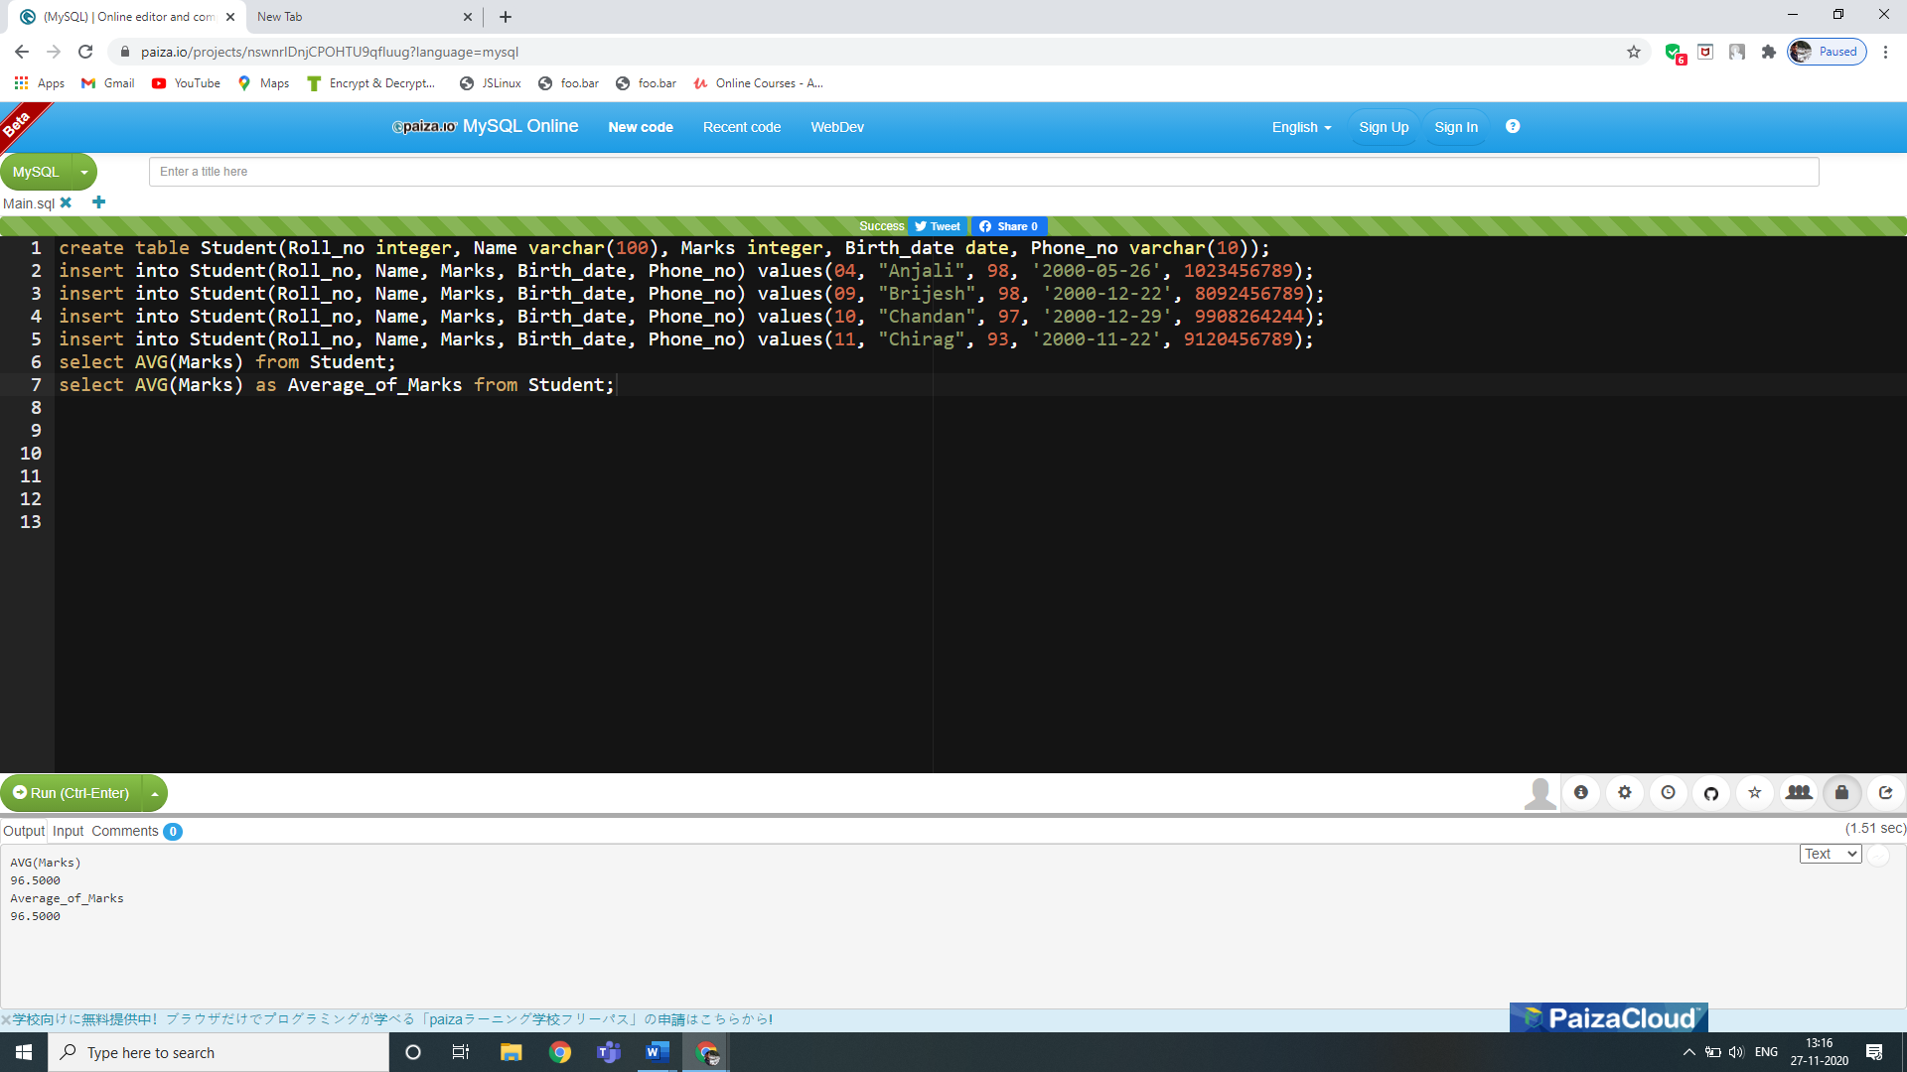

**Output-**



**19. How to use COUNT function to count rows ina specified table or view-**

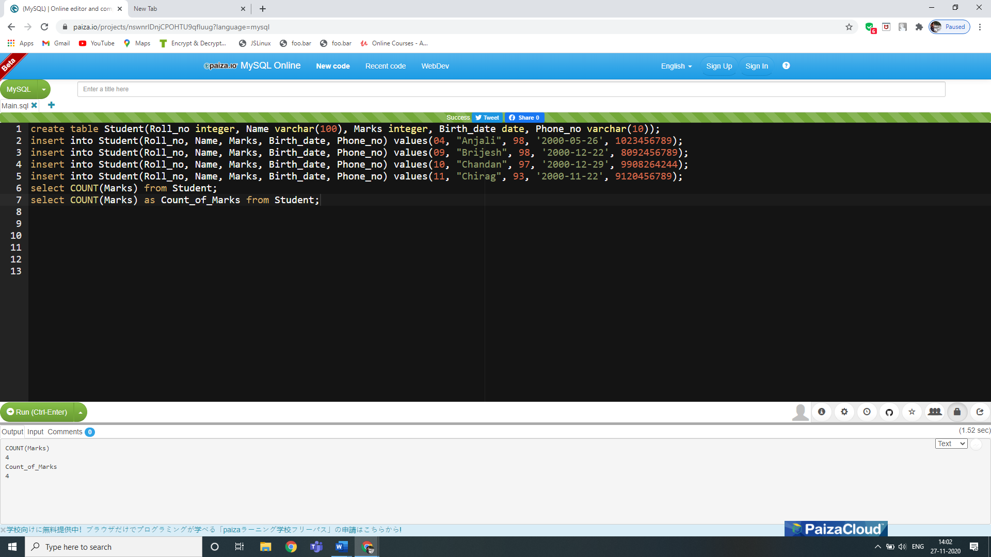

**Output-**



**20.**